Assignment -2

|  |  |
| --- | --- |
| Assignment Date | 12 September 2022 |
| Student Name | Nivetha p |
| Student Roll Number | 310119205020 |
| Maximum Marks | 2 Marks |

Question-1:

Create user table with user with email, username, roll number, password

CREATE TABLE user3 (

roll_number int, username varchar(300), email varchar(300),

password varchar(300)

);

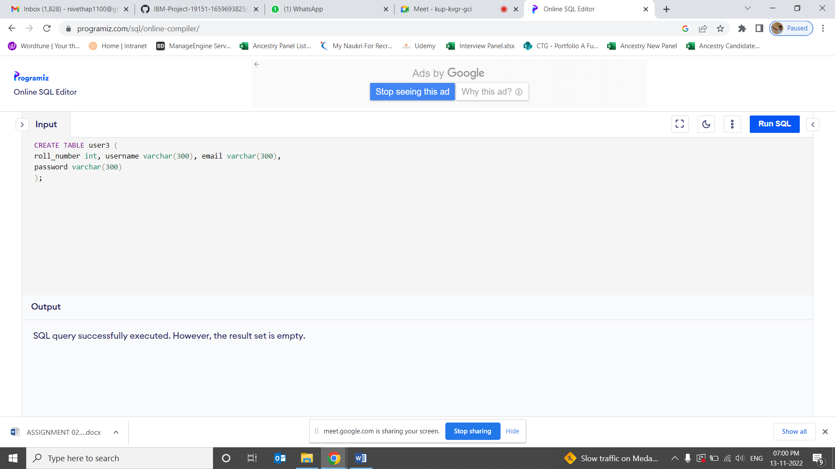

1. Perform UPDATE, DELETE Queries with user table

**INSERT Statement:**

# INSERT INTO users3( roll_number, username ,email, password) VALUES (1, 'Nivetha', 'nivetha80@gmail.com','nivetha80'),

(2, 'madhu', 'madhu@gmail.com','madhu1'),

# (3, 'akash', 'akash02@gmail.com','akash02'),

(4, 'pugal80', 'pugal06@gmail.com','pugal02'),

);

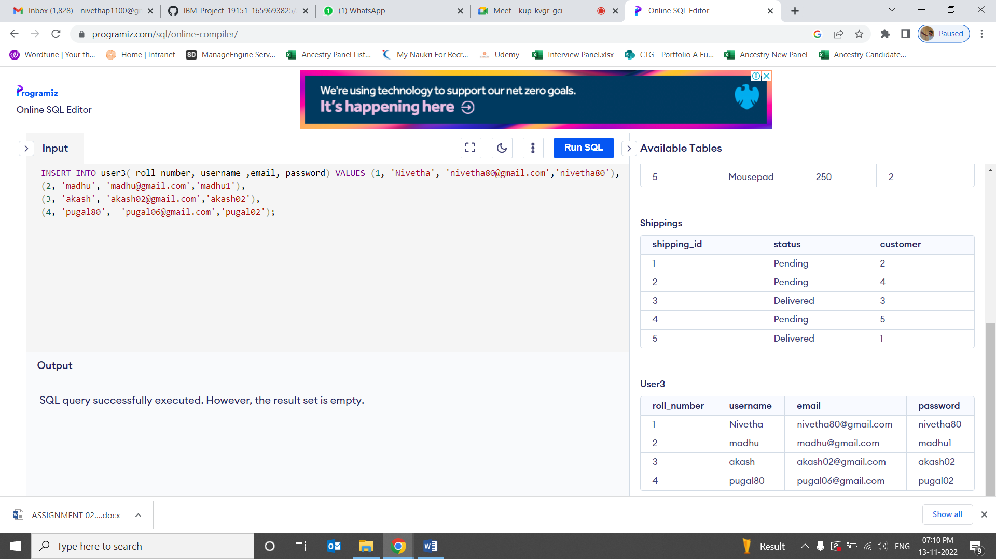

## UPDATE Statement:

UPDATE user3 SET username = 'Nivetha' WHERE roll_number = '2';

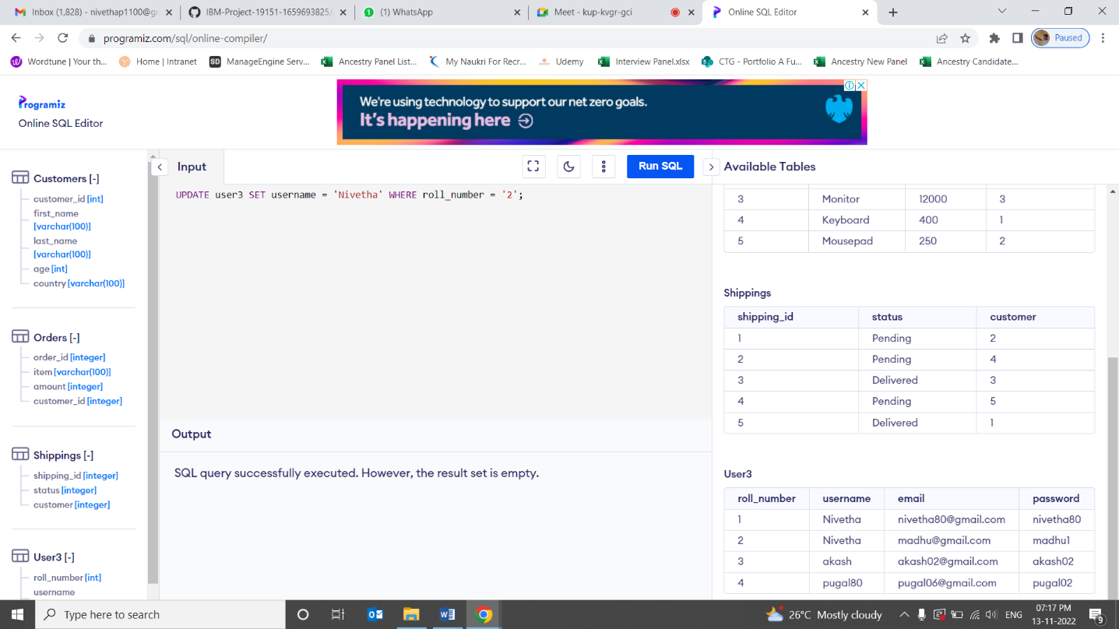

**Insert Statement:**

# INSERT INTO user3 values(5,'aa','aaa@gmail.com','aasdfg2') ;

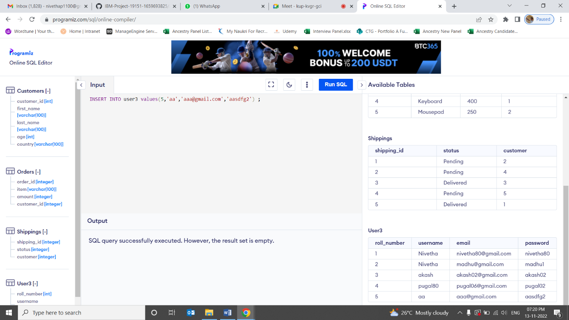

**DELETE Statement:**

DELETE FROM user3 where roll_number='5'

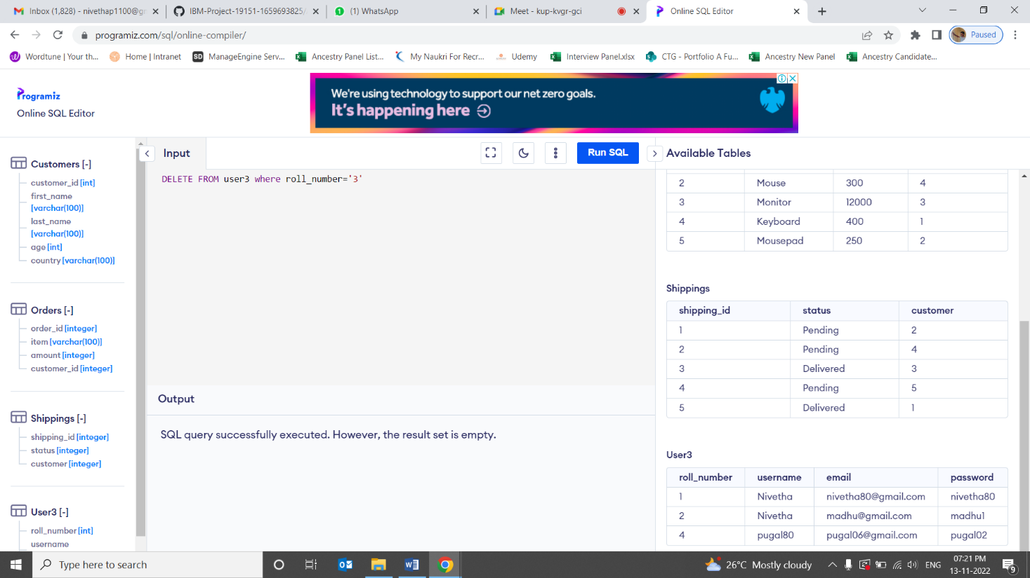

Connect python with db2

conn = ibm_db.connect("DATABASE=bludb;HOSTNAME=824dfd4d-99de-440d- 9991-

629c01b3832d.bs2io90l08kqb1od8lcg.databases.appdomain.cloud;PORT=30119;SE CURITY=SSL

;SSLServerCertificate=DigiCertGlobalRootCA.crt;UID=lvq43963;PWD=BsnsG1l2s BgIRhVN",' ','')

from flask import Flask, render_template, request, redirect, url_for, session from flask_mysqldb import MySQL

import MySQLdb.cursors import reapp = Flask( name )

app.secret_key = 'your secret key' app.config['MYSQL_HOST'] = 'localhost' app.config['MYSQL_USER'] = 'root' app.config['MYSQL_PASSWORD'] = 'your password' app.config['MYSQL_DB'] = 'geeklogin'

mysql = MySQL(app) @app.route('/')

@app.route('/login', methods =['GET', 'POST']) def login():

msg = ''if request.method == 'POST' and 'username' in request.form and 'password' in request.form:

username = request.form['username'] password = request.form['password']

cursor = mysql.connection.cursor(MySQLdb.cursors.DictCursor) cursor.execute('SELECT * FROM accounts WHERE username = % s AND password

= % s', (username, password, )) account = cursor.fetchone() if account:

session['loggedin'] = True session['id'] = account['id']

session['username'] = account['username'] msg = 'Logged in successfully !'

return render_template('index.html', msg = msg)

else:

msg = 'Incorrect username / password !'

return render_template('login.html', msg = msg)

@app.route('/logout') def logout():

session.pop('loggedin', None) session.pop('id', None) session.pop('username', None) return redirect(url_for('login'))

@app.route('/register', methods =['GET', 'POST']) def register():

msg = ''

if request.method == 'POST' and 'username' in request.form and 'password' in request.form and 'email' in request.form :

username = request.form['username'] password = request.form['password'] email = request.form['email']

cursor = mysql.connection.cursor(MySQLdb.cursors.DictCursor) cursor.execute('SELECT * FROM accounts WHERE username = % s', (username, )) account = cursor.fetchone()

if account:

msg = 'Account already exists !'

elif not re.match(r'[^@]+@[^@]+\.[^@]+', email): msg = 'Invalid email address !'

elif not re.match(r'[A-Za-z0-9]+', username):

msg = 'Username must contain only characters and numbers !' elif not username or not password or not email:

msg = 'Please fill out the form !'

else:

cursor.execute('INSERT INTO accounts VALUES (NULL, % s, % s, % s)',

(username, password, email, ))

mysql.connection.commit()

msg = 'You have successfully registered !' elif request.method == 'POST':

msg = 'Please fill out the form !'

return render_template('register.html', msg = msg)

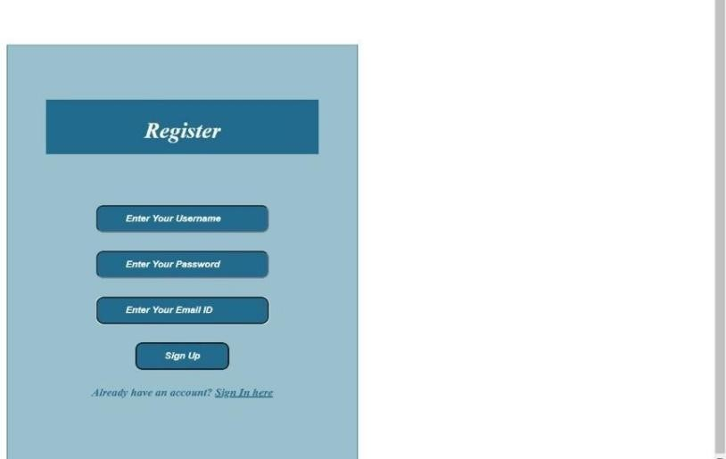

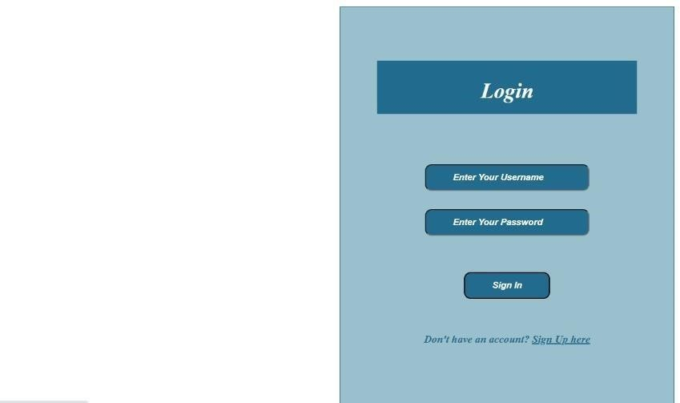



## 3) Write a flask program which should display resume details and also have upload resume option

**by using file uploading.**

## UPLOAD.PY:

from flask import *

app = Flask( name )

@app.route('/') def upload():

return render_template("file_upload_form.html")

@app.route('/success', methods = ['POST']) def success():

if request.method == 'POST': f = request.files['file'] f.save(f.filename)

return render_template("success.html", name = f.filename)

if name == ' main ': app.run(debug = True)

## FILE_UPLOAD_FORM.HTML:

<html>

<head>

<title>upload</title>

</head>

<body>

<form action = "/success" method = "post" enctype="multipart/form-data">

<input type="file" name="file" />

<input type = "submit" value="Upload">

</form>

</body>

</html>

## SUCCESS.HTML:

<html>

<head>

<title>success</title>

</head>

<body>

<p>File uploaded successfully</p>

<p>File Name: {{name}}</p>

</body>

</html>

## OUTPUT:

